**Applied DBMS Lab Assignment 1**



*Submitted by:-* **Sanyam Jain**

Section- **C**

Roll No. **69**

**Ques 1:**

**Table creation>>>>**

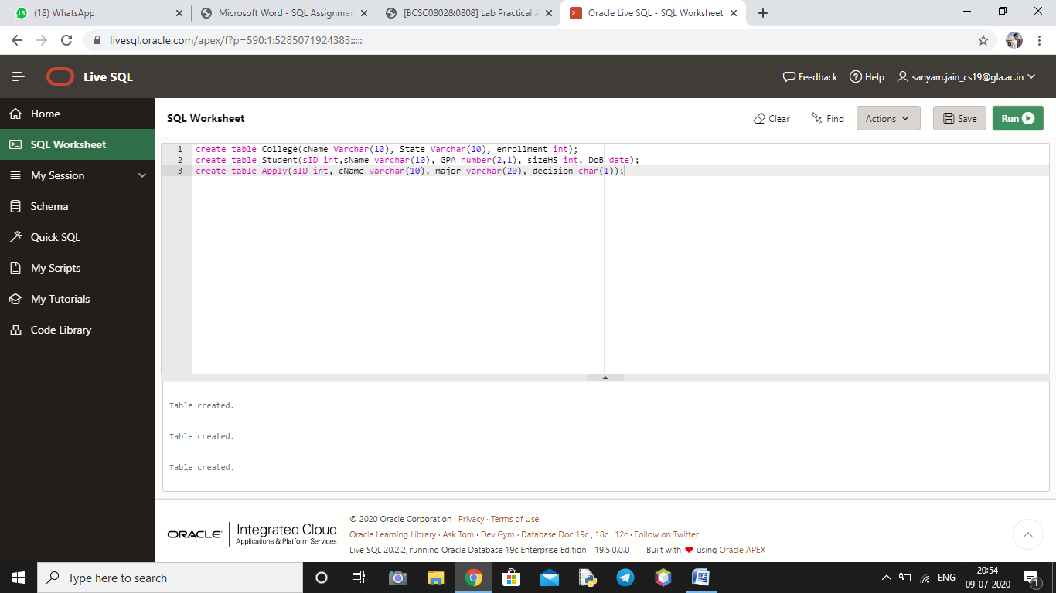

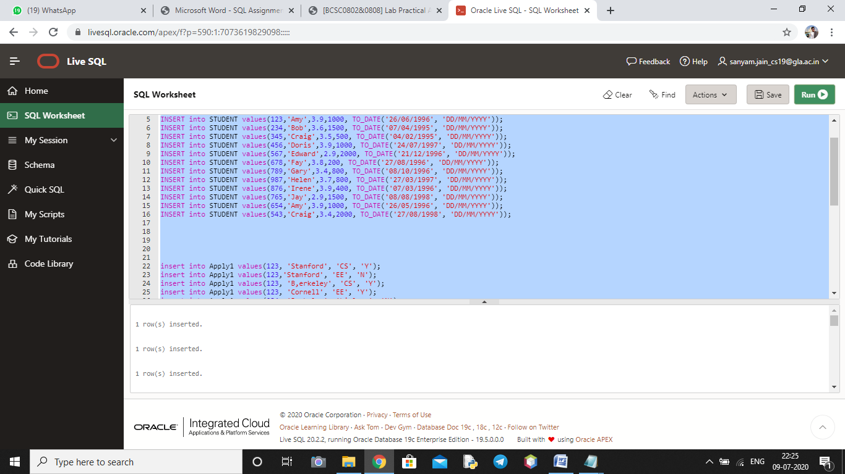

Queries: -

**Query 1>>>**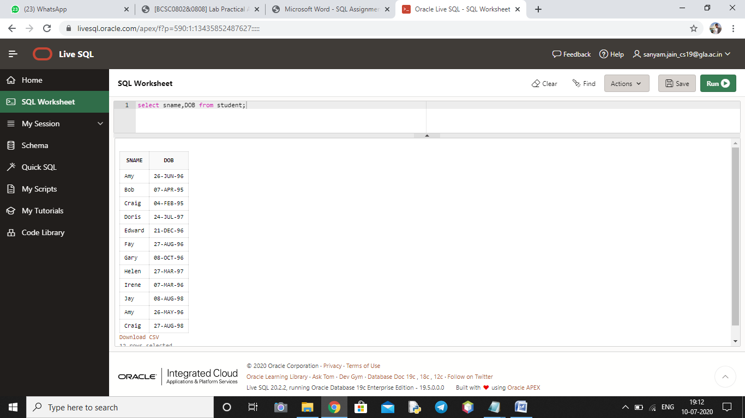

**Query 2>>>**

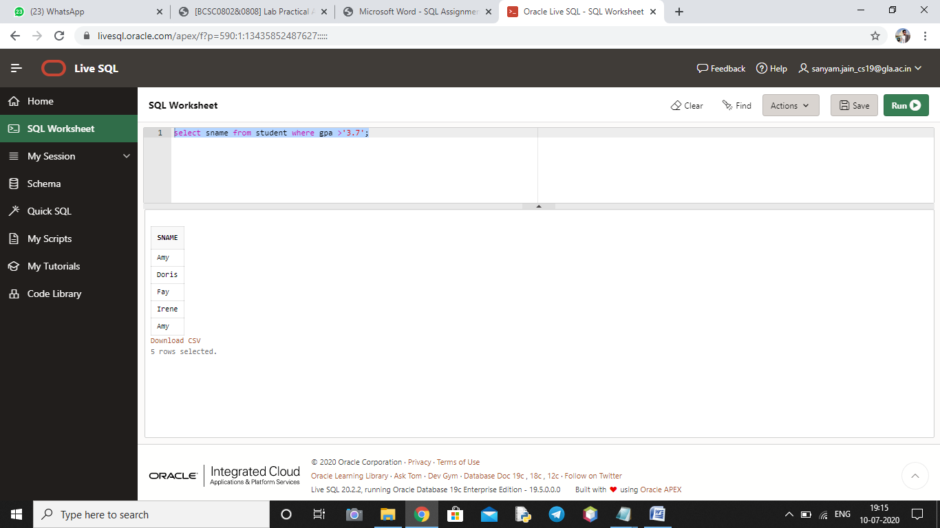

**Query 3>>>**

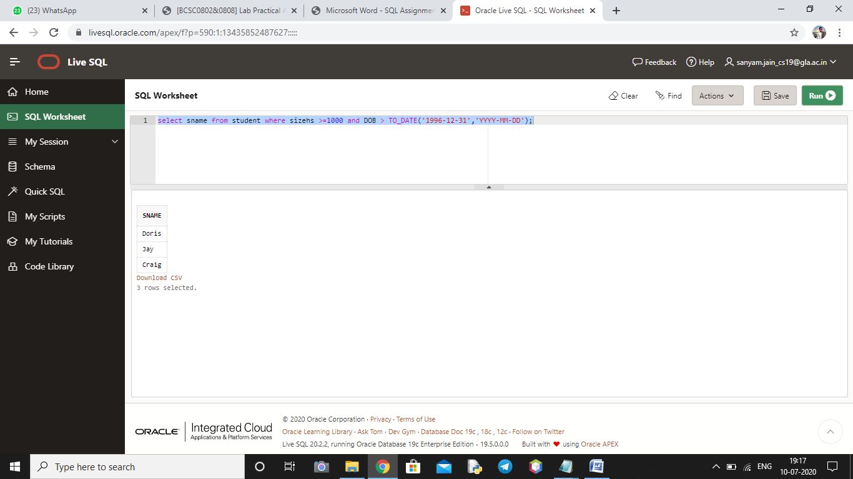

**Query 4>>>**

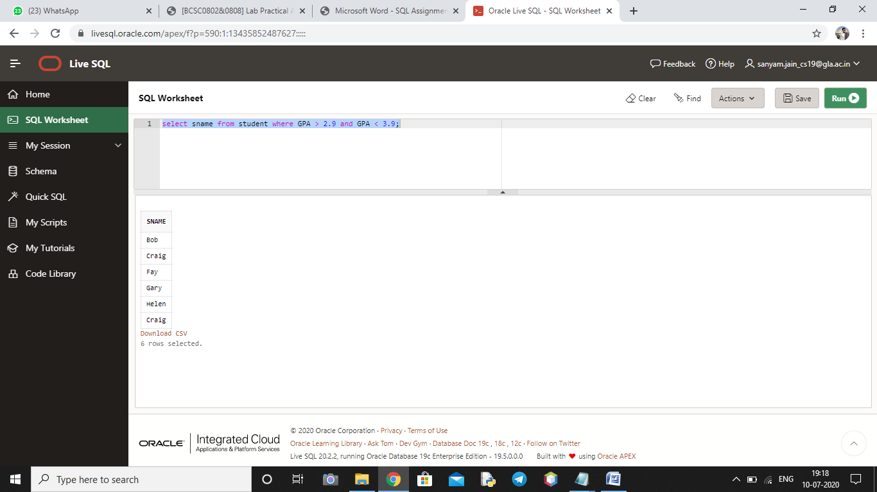

**Query 5>>>**

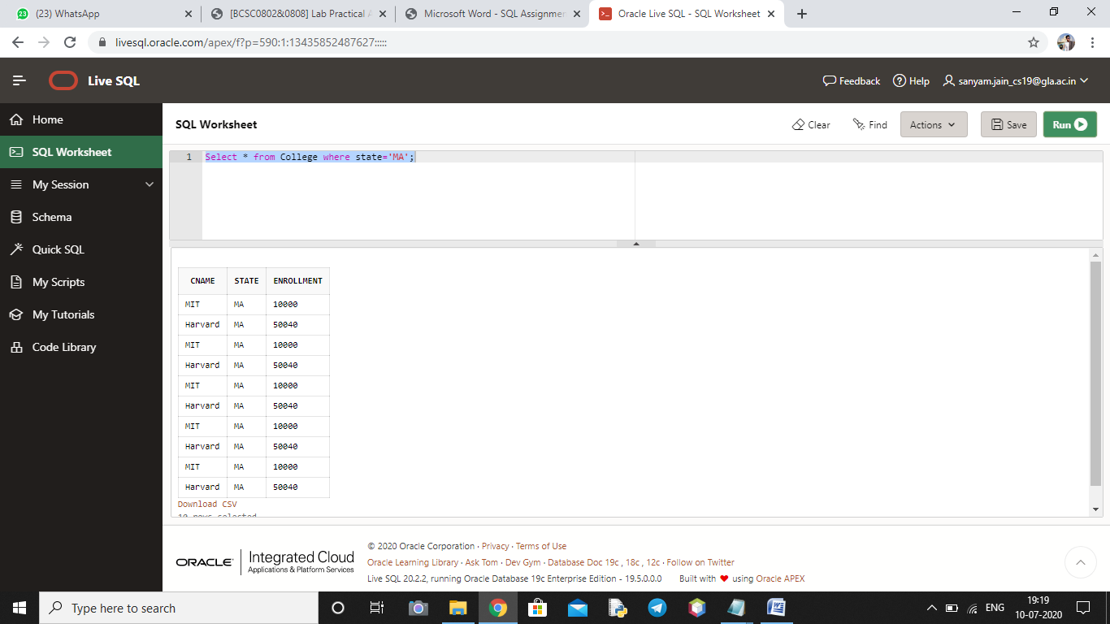

**Query 6>>>**

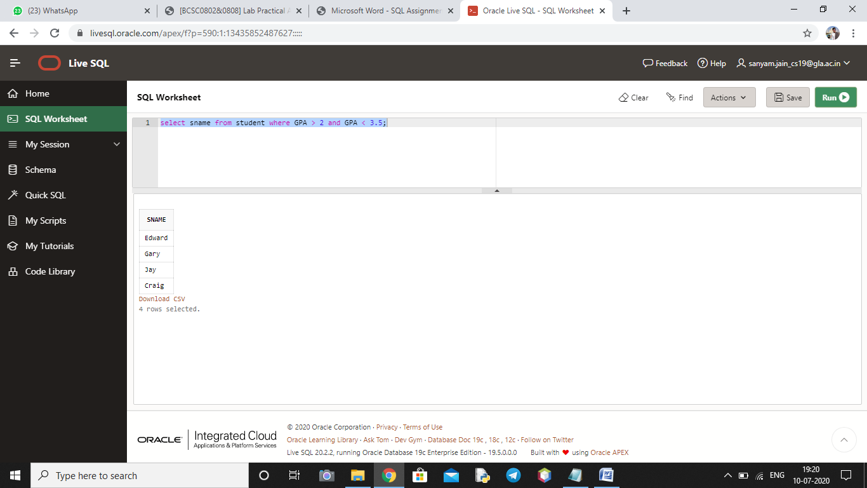

**Query 7>>>**

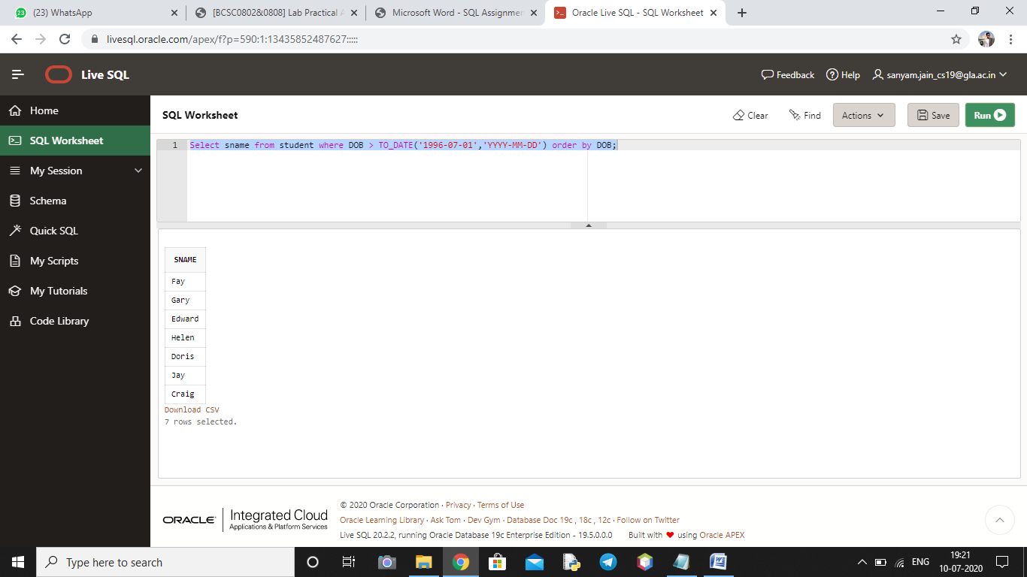

**Query 8>>>**

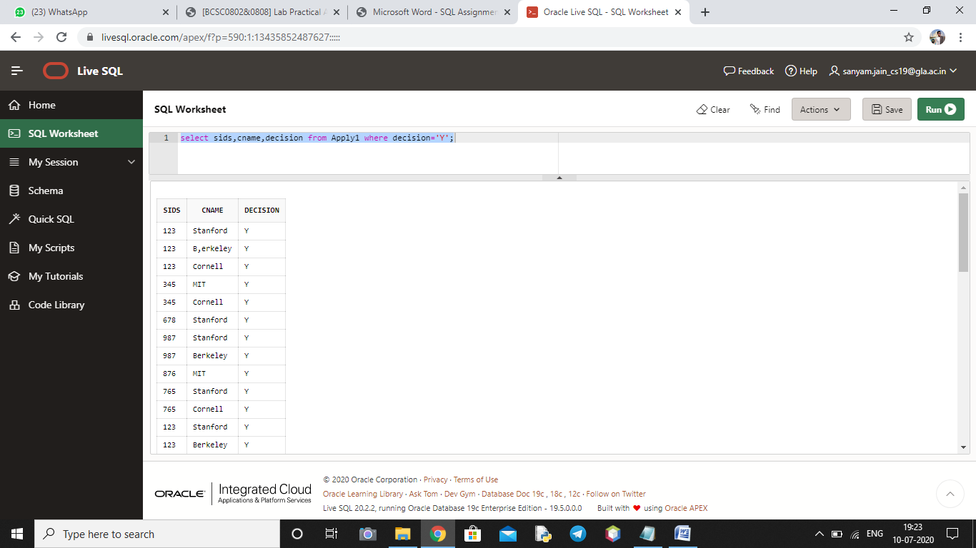

**Query 9>>>**

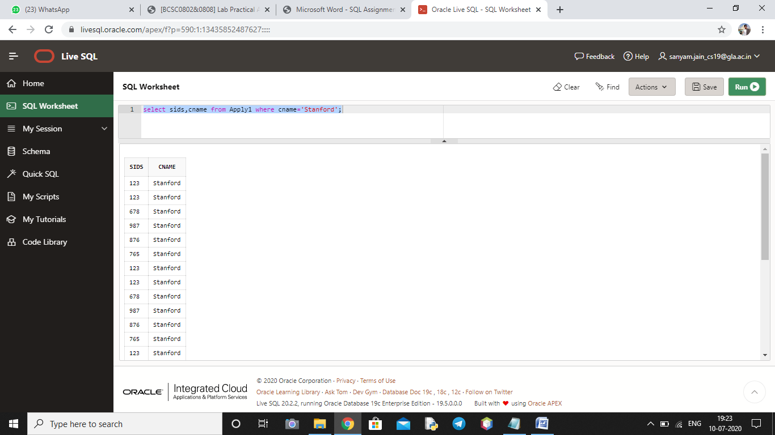

**Query 10>>>**

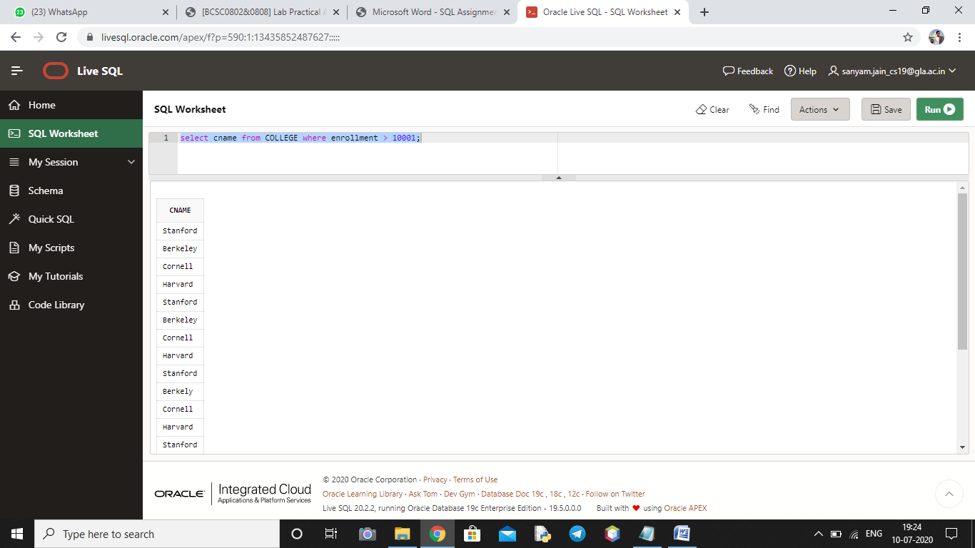

**Query 11>>>**

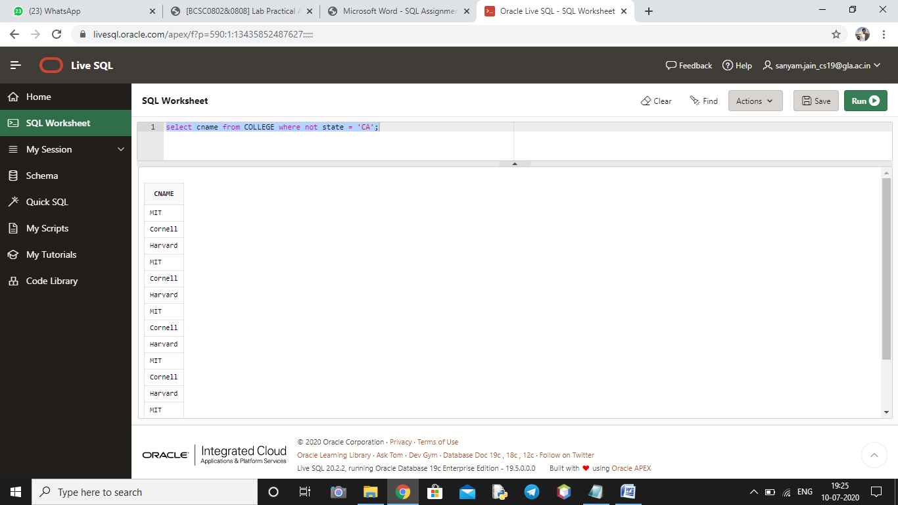

**Query 12>>>**

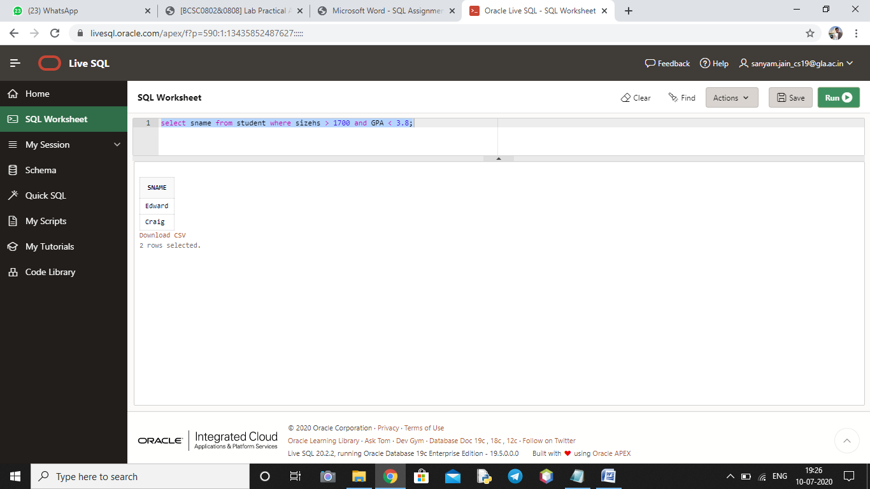

**Query 13>>>**

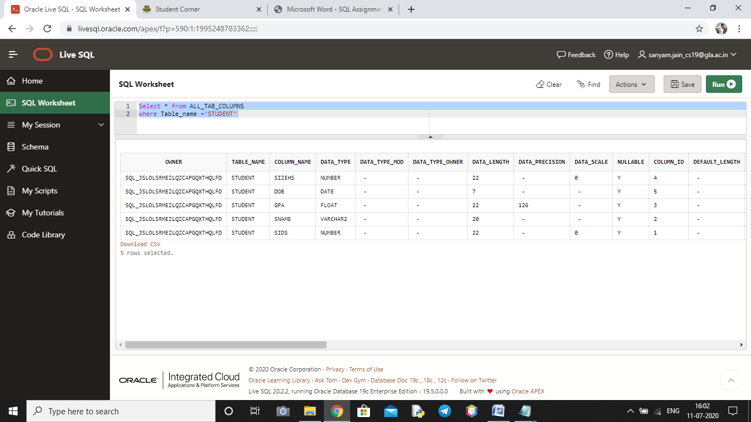

**Query 14>>>**

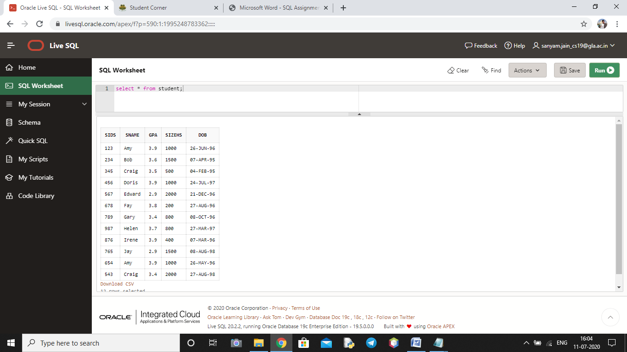

**Query 15>>>**

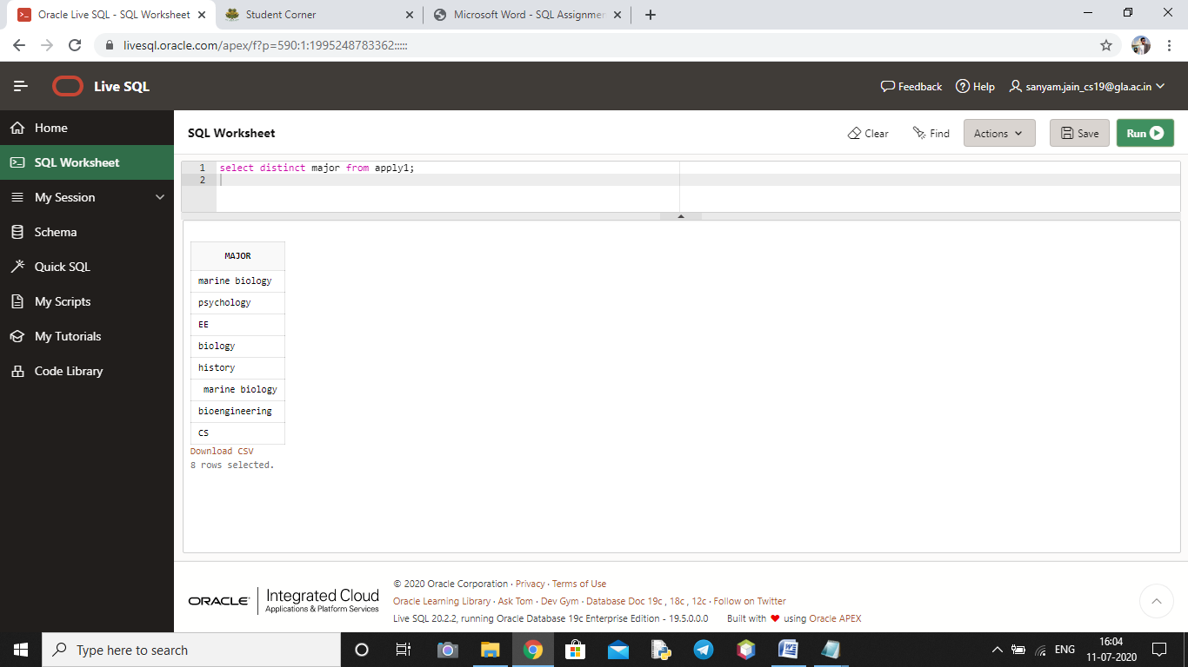

**Query 16>>>**

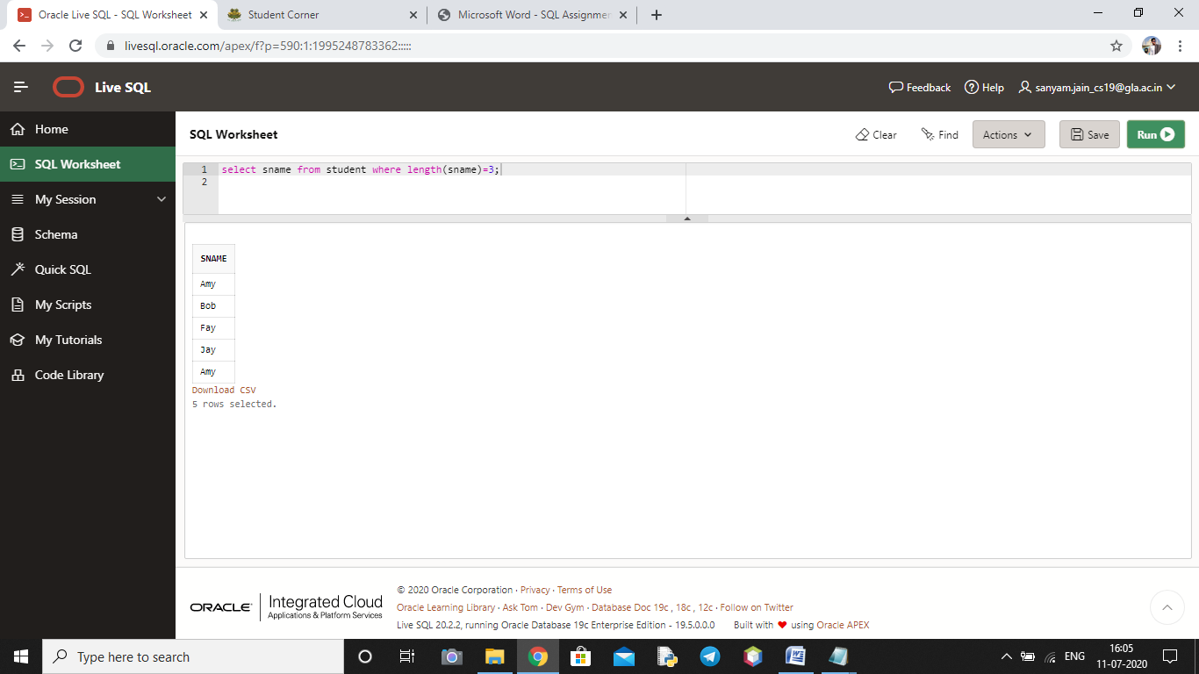

**Query 17>>>**

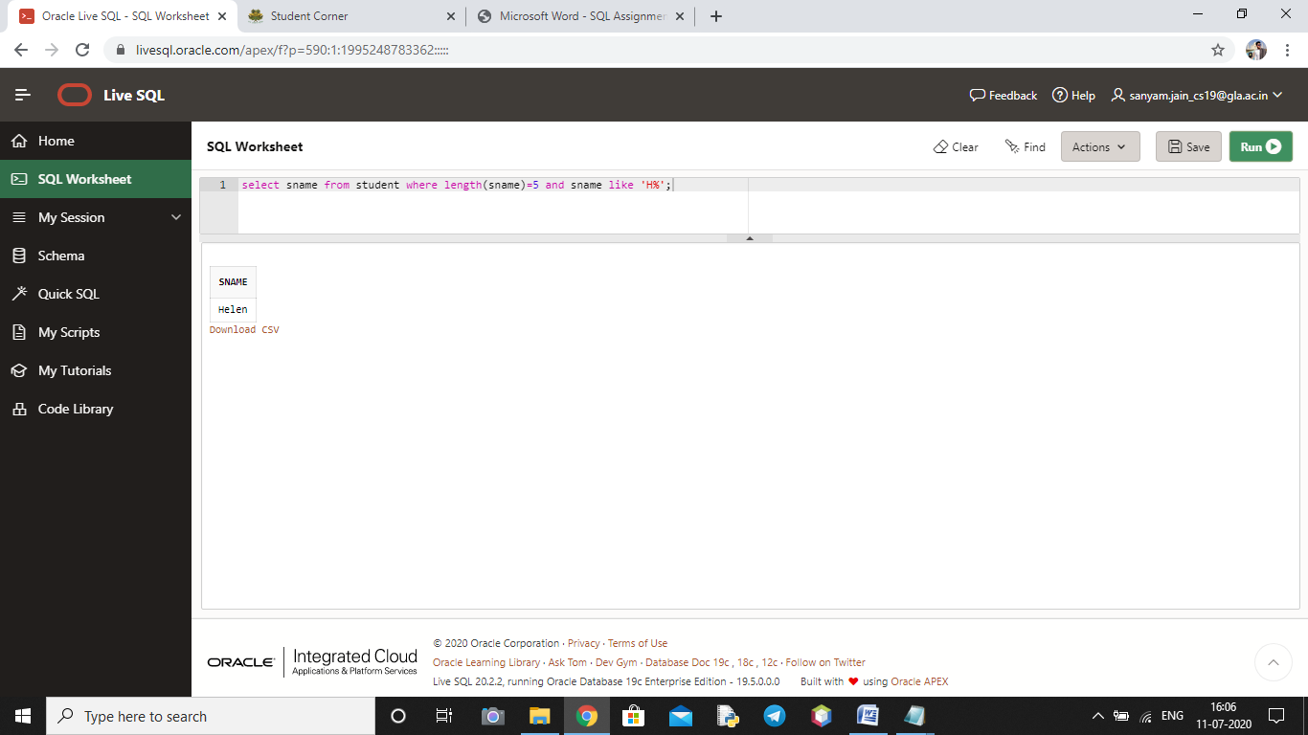

**Query 18>>>**

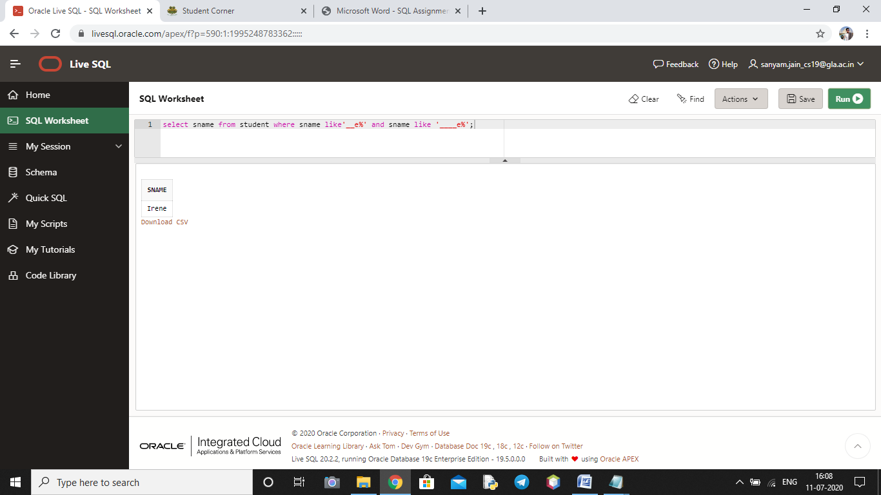

**Query 19>>>**

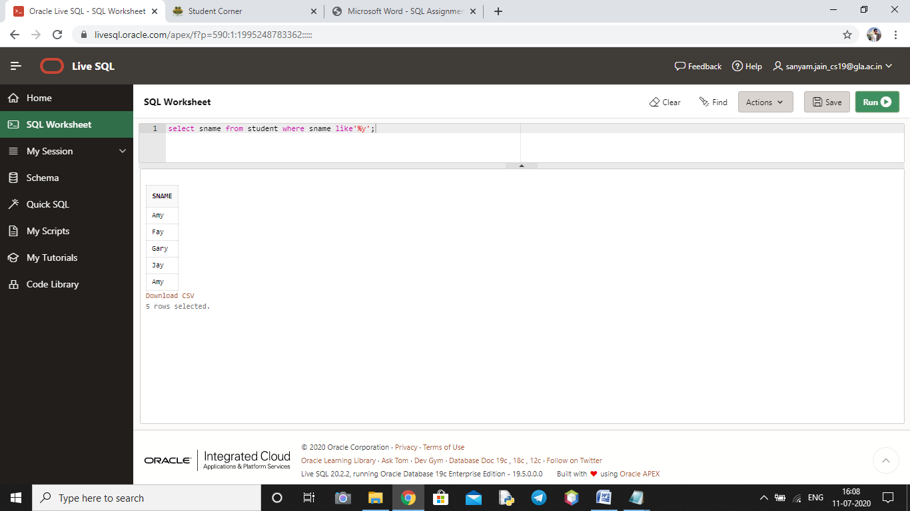

**Query 20>>>**

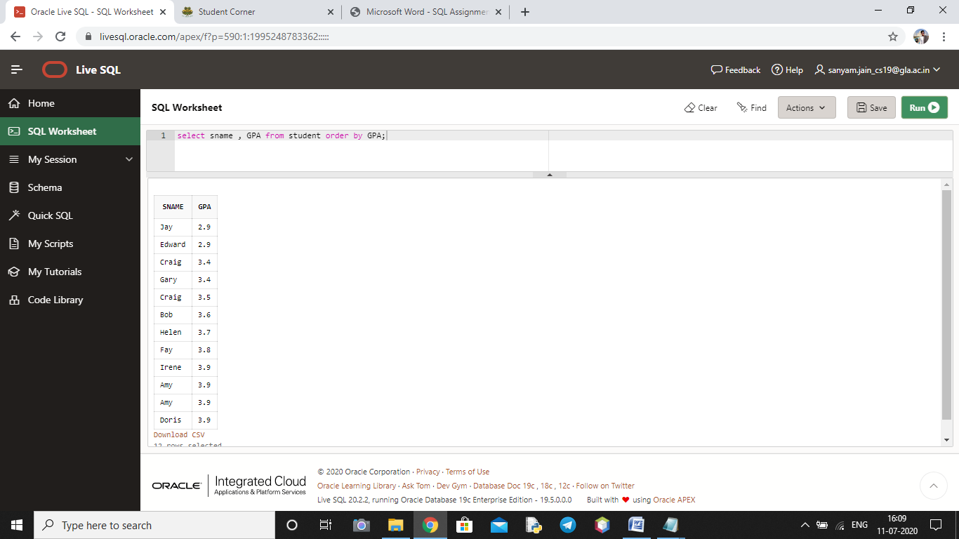

**Query 21>>>**

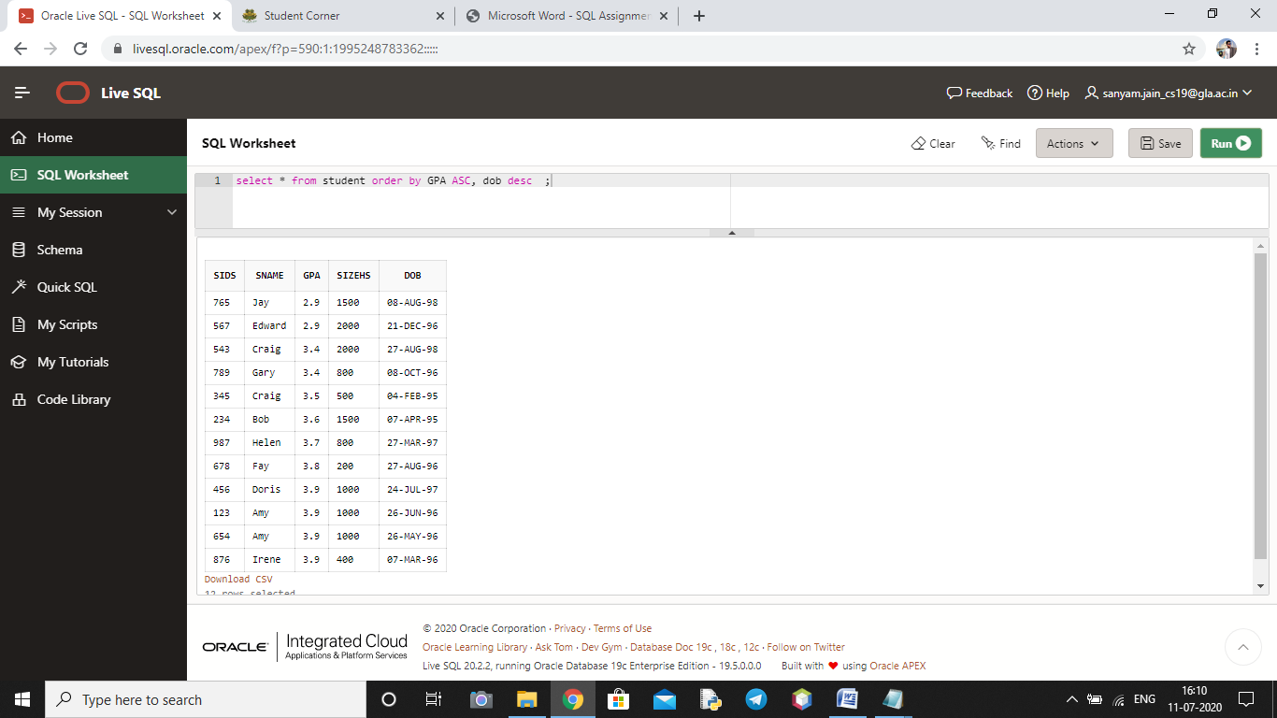

**Query 22>>>**

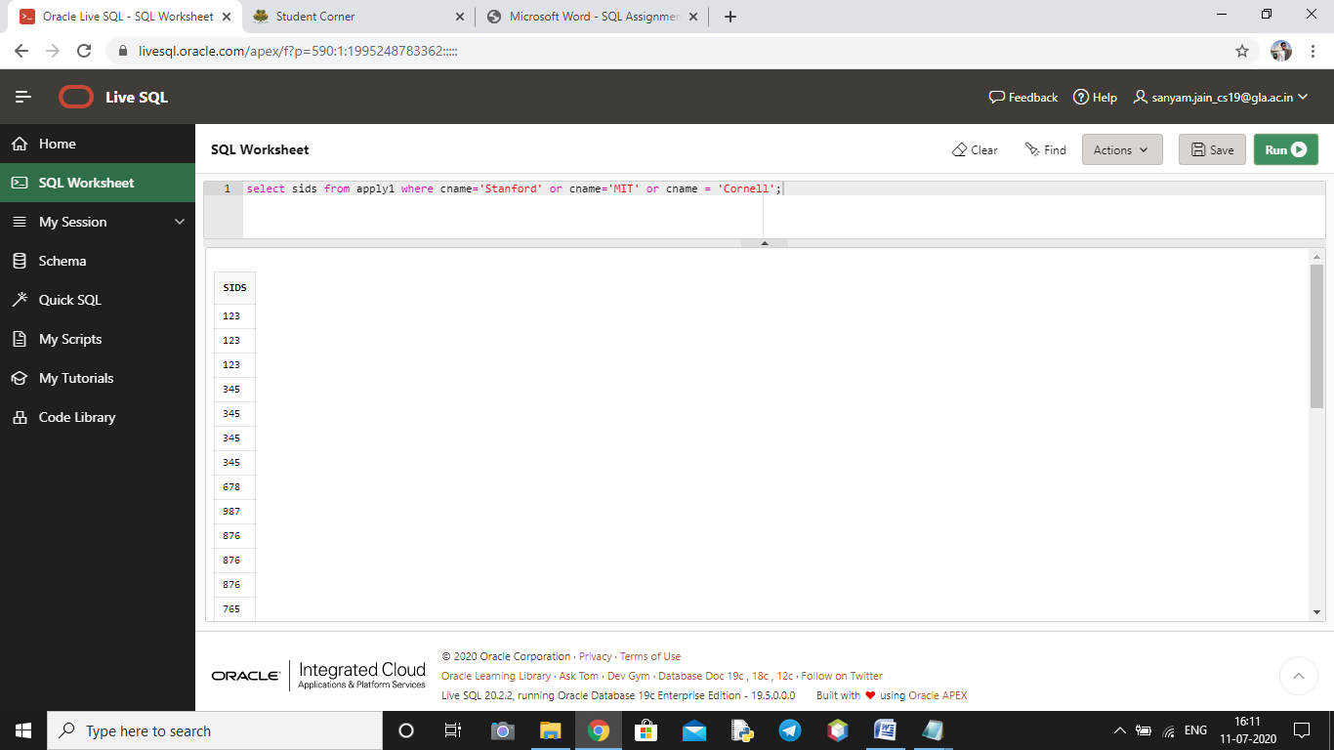

**Query 23>>>**

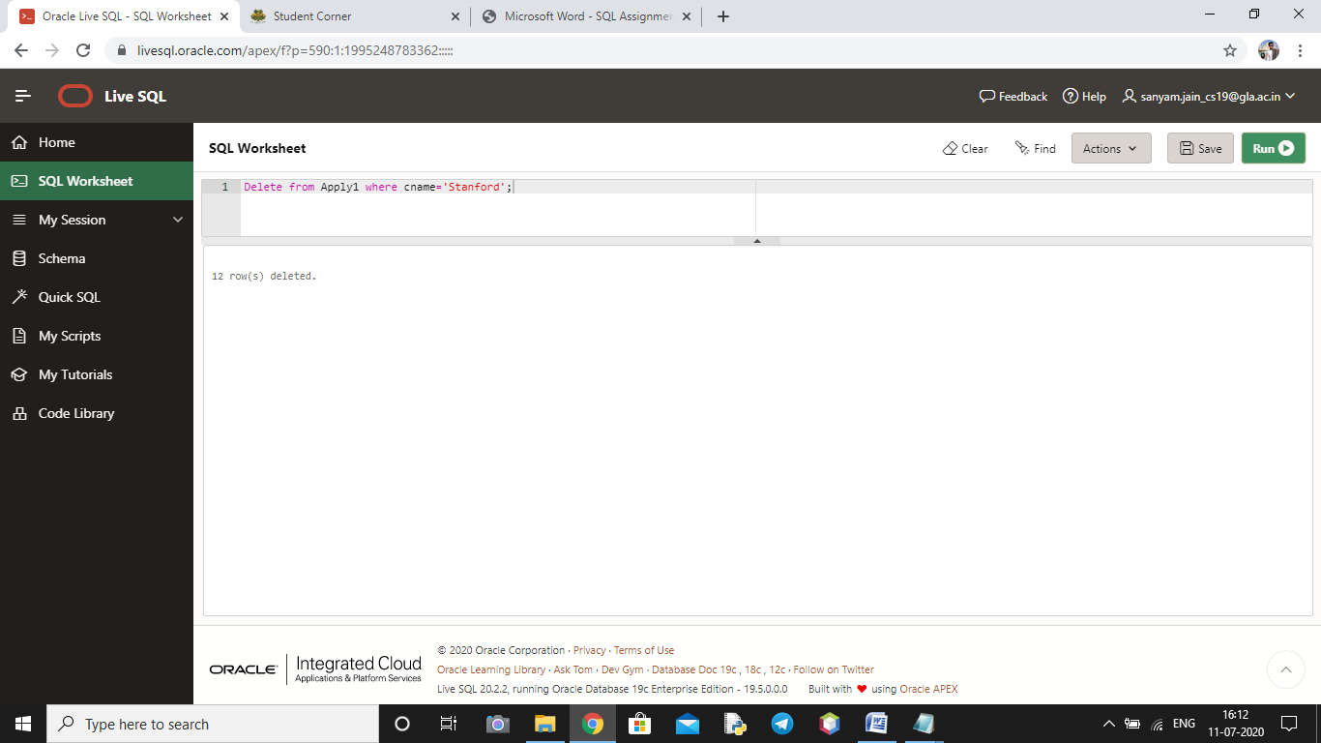

**Query 24>>>**

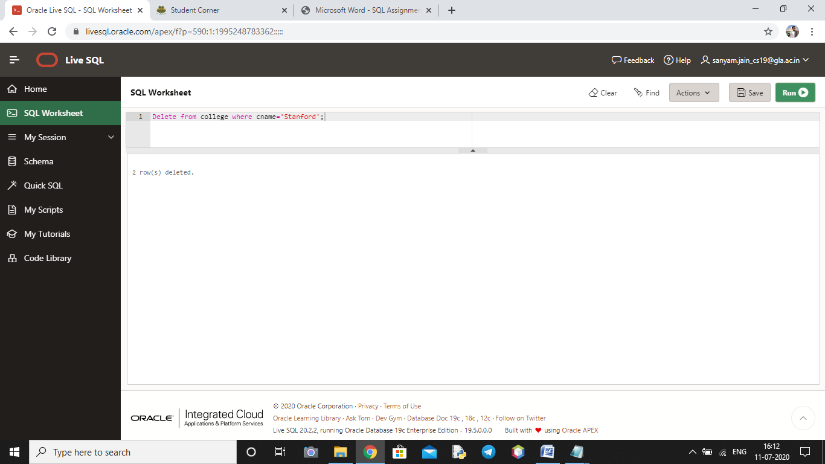

**Query 25>>>**

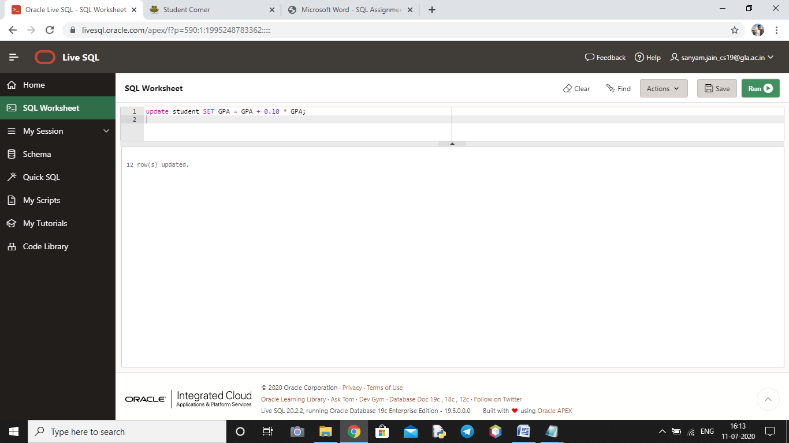

**Query 26>>>**

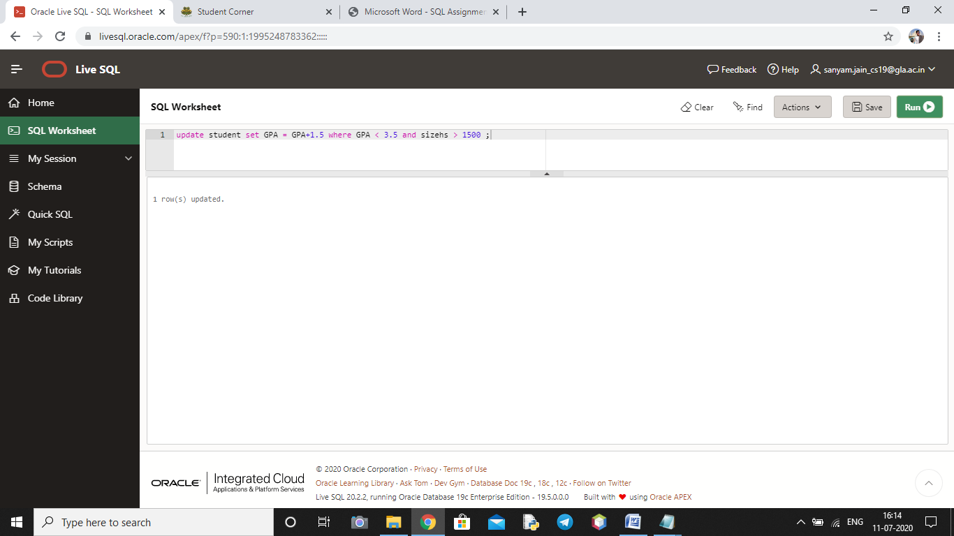

**Query 27>>>**

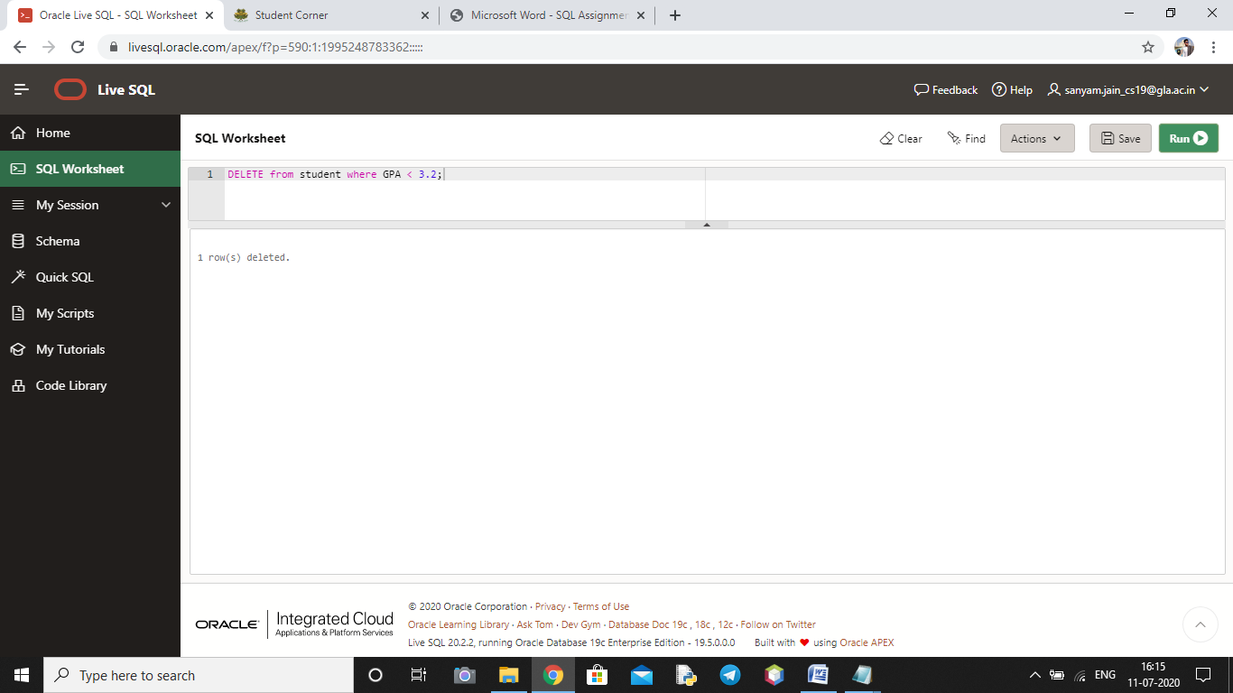

**QUERIES 2 >>>>**

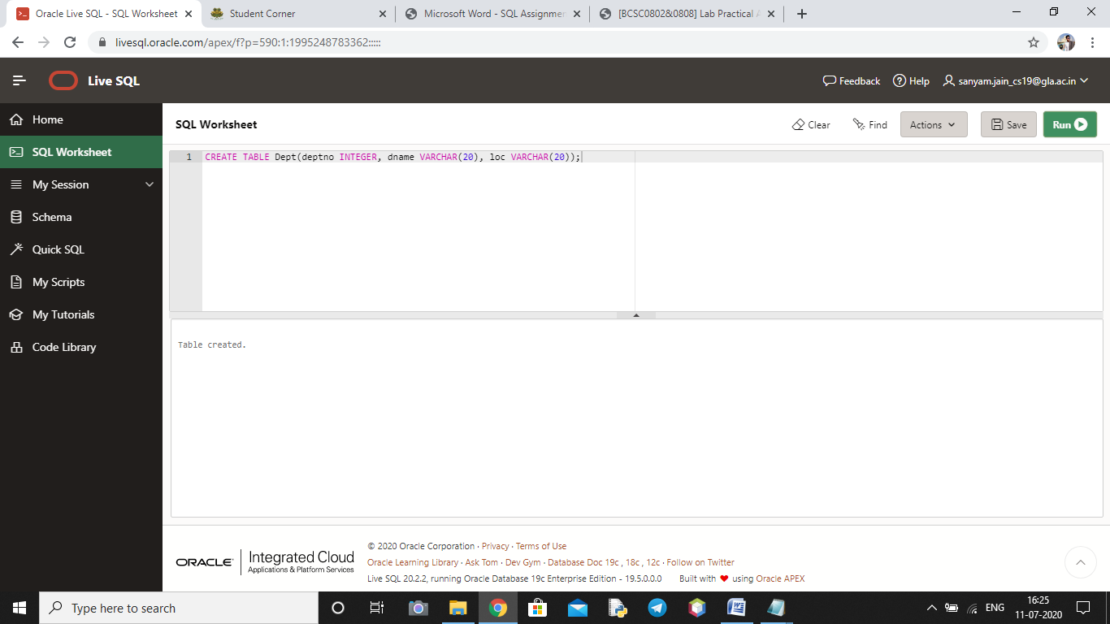

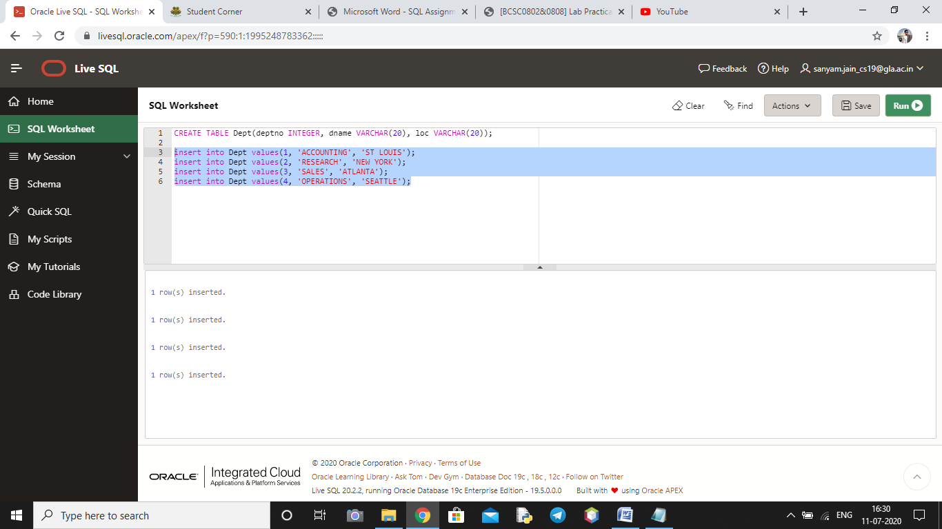

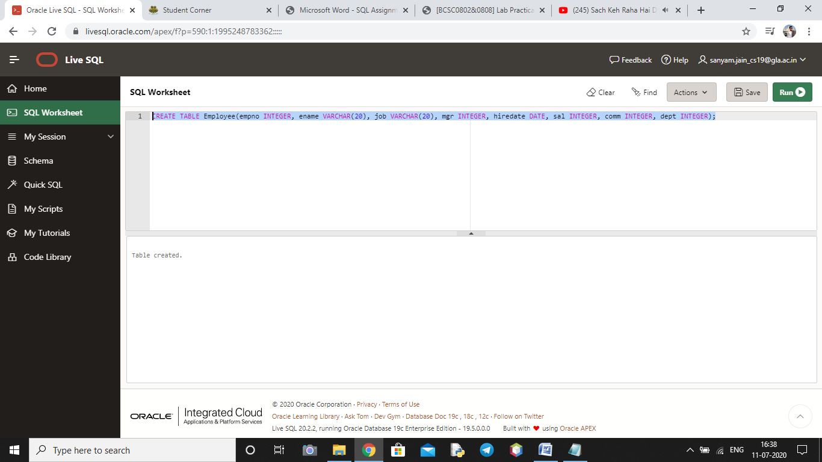

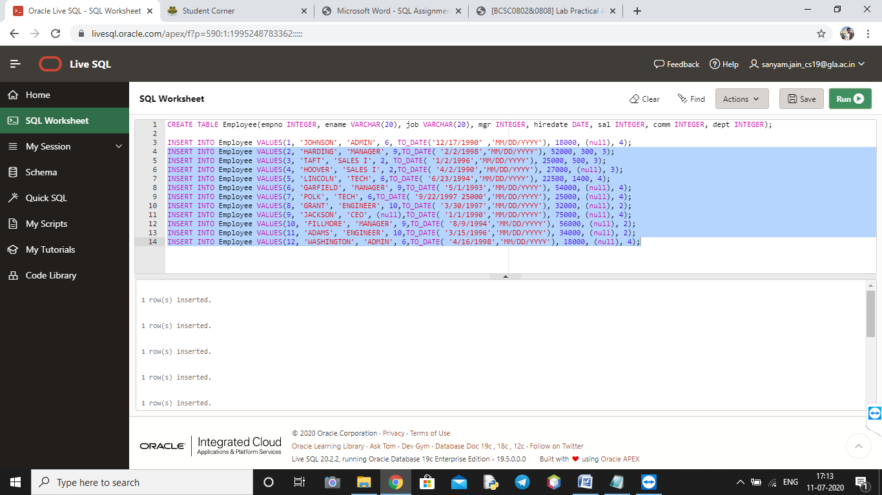

**Query 1>>>**

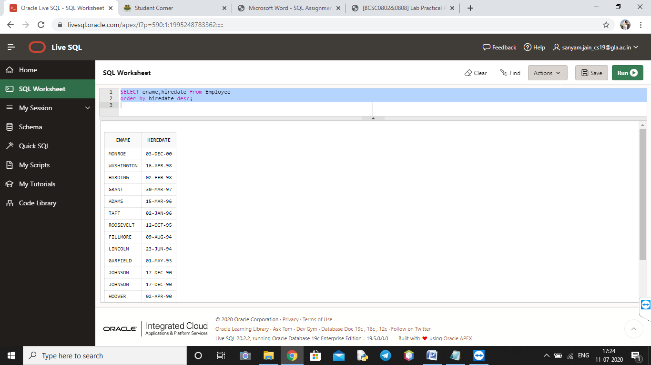

**Query 2>>>**

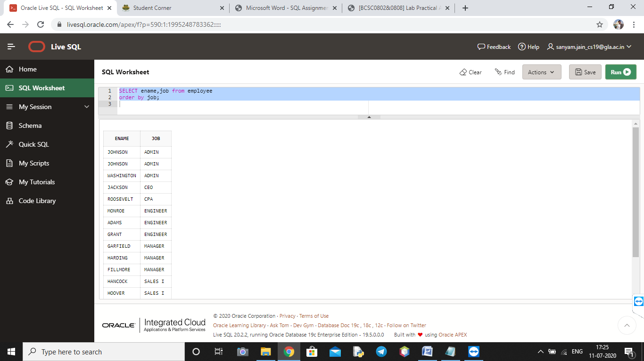

**Query 3>>>**

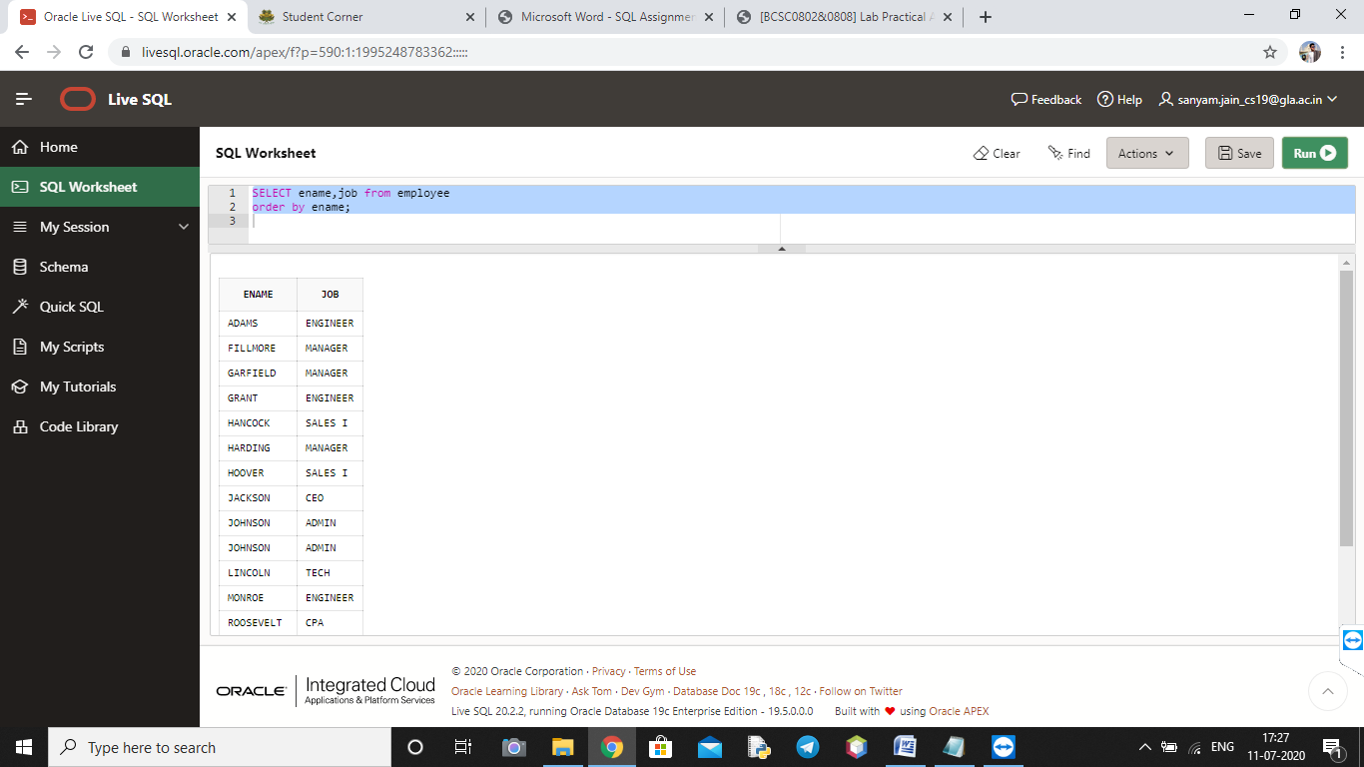

**Query 4>>>**

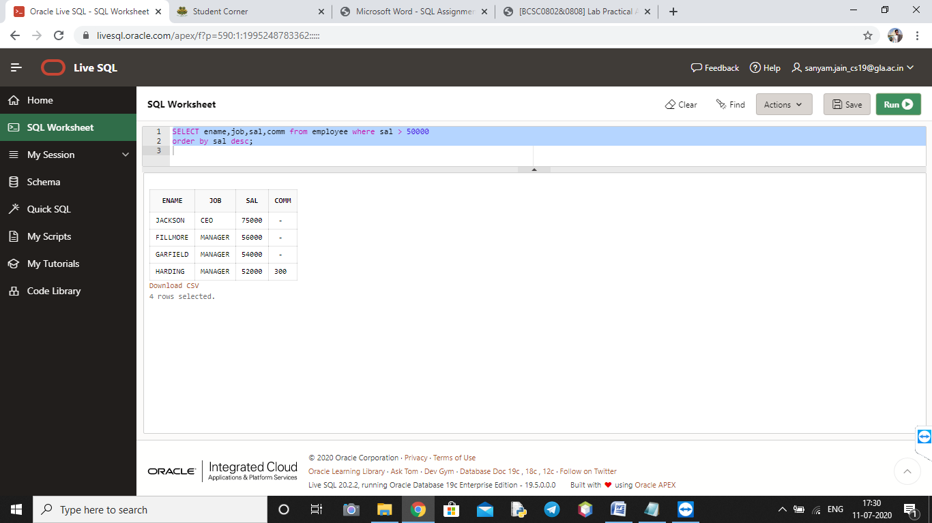

**Query 5>>>**

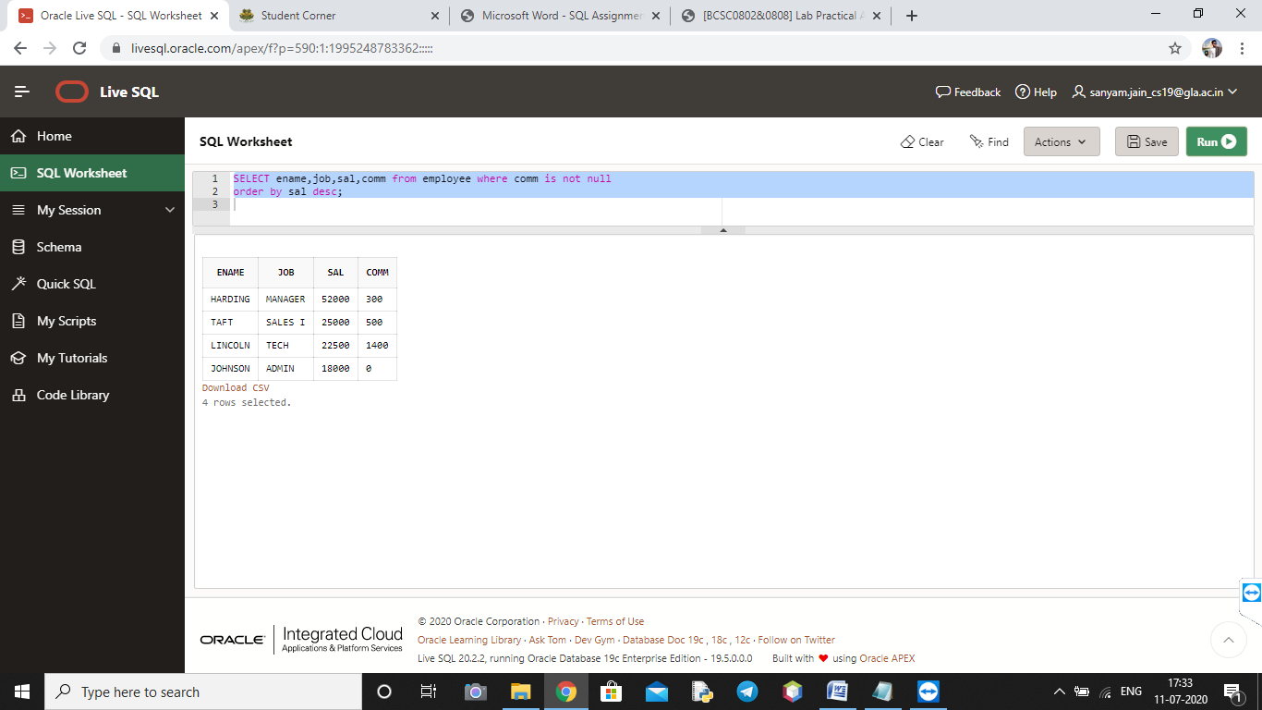

**Query 6>>>**

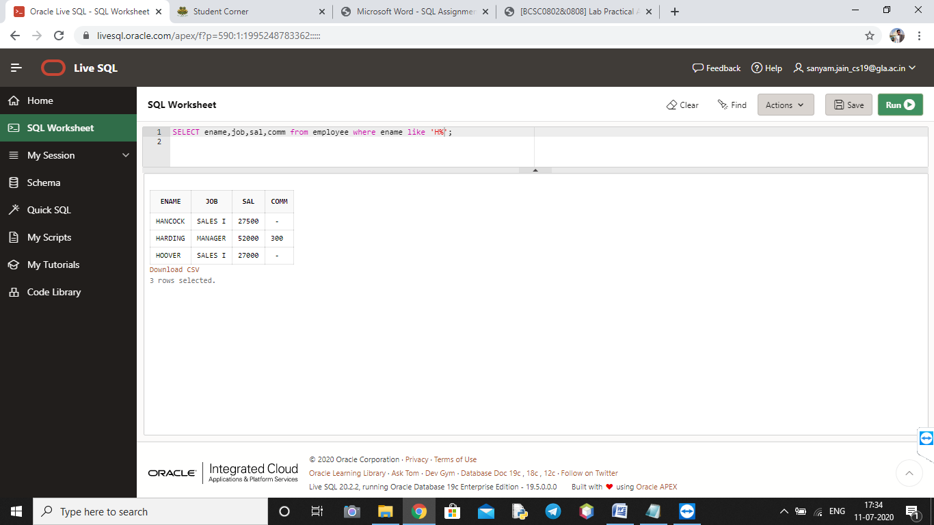

**Query 7>>>**

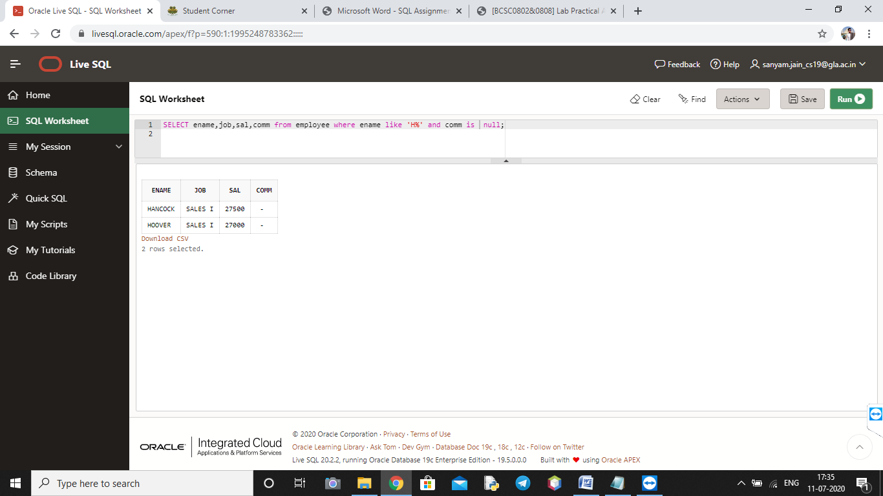

**Query 8>>>**

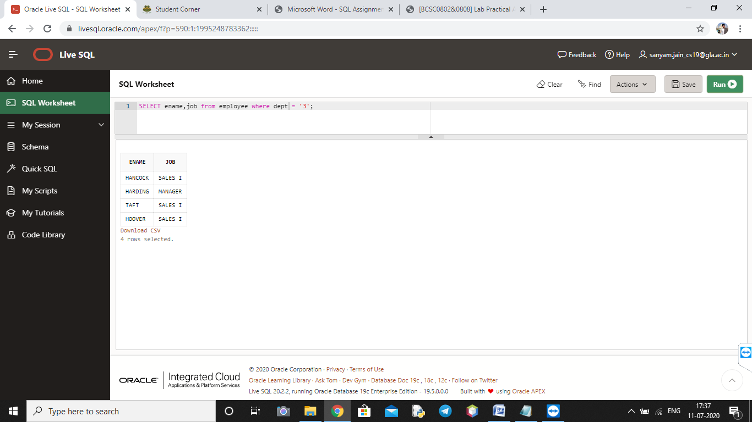

**Query 9>>>**

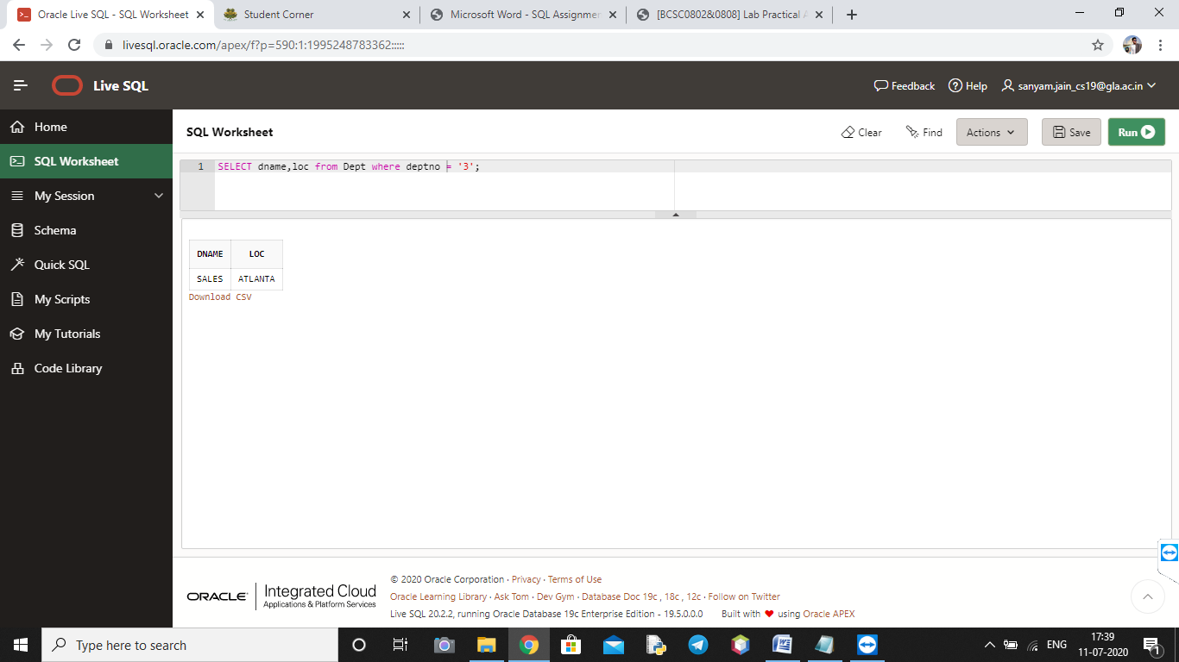

**Query 10>>>**

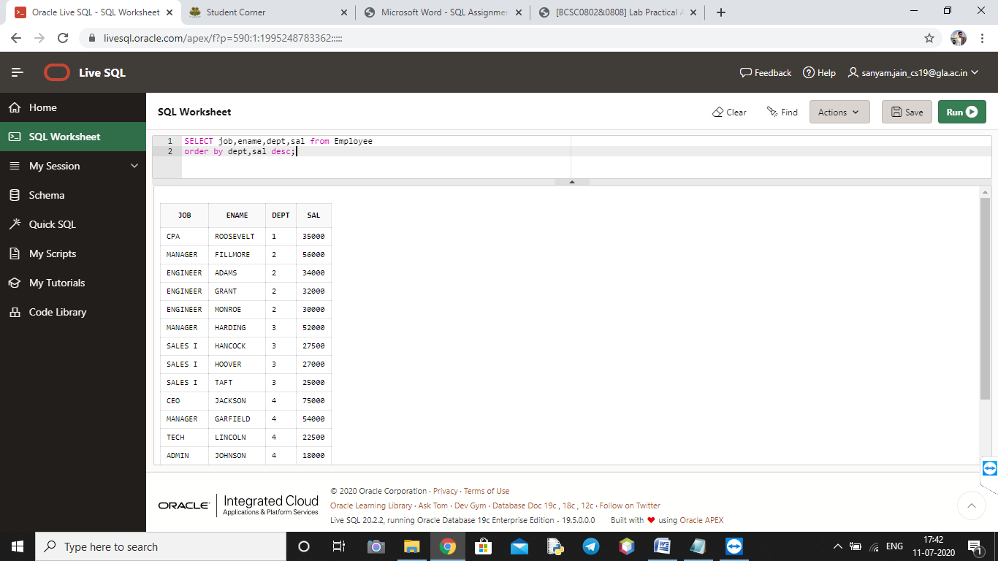

**Pre Experiment Questions**

**Q1 What is Relation?**

Relation between two tables exist if one or more column is present in both the tables.

For example:

There is a CUSTOMER_MASTER table that stores customer data, with a primary key column called CustID, as well as an ACCOUNTS_MASTER table for holding information about various bank accounts and which customer owns them. To link these two tables together, that is to tie each customer to his or her bank account, a corresponding CustID column is required in the ACCOUNTS_MASTER table that references an already-existing customer ID in the CUSTOMER_MASTER table. In this case, the CustID column in ACCOUNTS_MASTER is a foreign key that references the column of the same name in CUSTOMER_MASTER. This scenario refers to the relation between the two tables.

**Q2 What are attributes?**

A database attribute is a column name and the content of the fields under it in a table.

**Q3 What are different DML commands?**

•SELECT

• INSERT

• UPDATE

• DELETE

**Q4 What is the need of pattern matching?**

SQL pattern matching allows you to search for patterns in data if you don't know the exact word or phrase you are seeking. This kind of SQL query uses wildcard characters to match a pattern, rather than specifying it exactly.

**Post Experiment Questions**

**Q1 Difference between DDL and DML?**

Data Definition Language (DDL) defines the schema of the Database whereas the Data Manipulation Language (DML) is used to modify the schema of the Database.

**Q2 How to create a Table?**

Syntax to create table:

CREATE TABLE tablename ( Column1 data type, Column2 data type, Column3 data type, ... );

**Q3 What is the difference between truncate and delete?**

TRUNCATE is the DDL statement whereas DELETE is a DML statement. TRUNCATE always removes all the rows from a table, leaving the table empty and the table structure intact whereas DELETE may remove conditionally if the ‘where’ clause is used.

**Q4 How we use IN command?**

The IN operator is a shorthand for multiple OR conditions.

Syntax:

SELECT column_name(s)

FROM table_name

WHERE column_name IN (value1, value2, ...);

